Unit 3 I’m more outgoing than my sister.
Section B 2a-2e 学案
学习目标 | - 语言能力：通过阅读了解Jeff Green，Huang Lei，Mary Smith 和他们好朋友之间的异同，复习巩固比较级在具体语境中的灵活使用。  - 学习能力：学生通过读图和留意名字的大写字母，能快速找出关键信息；并能够快速找到主旨句；能够选用恰当的形容词和副词的比较级来进行两者比较。  - 思维品质：帮助学生知晓更多的朋友观，思考朋友的真正意义。  - 文化意识：进一步了解中外学生的择友标准。
学习  重难点 | 重点：本课文中所涉及到的与朋友话题相关的新词汇和表达:正确熟练运用形容词及副词的比较级比较两者间的不同点，使用both, as...as.结构描述两者间相同之处;利用预测、略读、跳读等阅读策略的训练。  难点：阅读文章之后，表达与朋友的对比，发表自己对朋友和友谊的看法，思考朋友的真正意义。
自学指导 | 自学检测及课堂展示
定向自学 | 一、英汉互译  1. 必要的、必须的 2. 小孩、年轻人 3. 谚语、格言  4. serious 5. mirror 6. as long as______________7. In fact_______________  8. bring out the best in me_________________  二、根据句意及汉语提示完成句子  1．Mr. Li is more ___________(严肃的) than any other teacher，so we are all afraid of him.  2．The apples on the tree are too tall. I can't _________(够到) them.  3．It is ___________(有必要的) to learn a foreign language.  4．My mother always ____________(感动) my heart.  5．You should ___________(分享) your toys with your friends.
情景导入 | 1. Watch a video  2. What kind of things are important to a friend? I think a good friend ________________.
定向自学&  合作研学&  展示激学 | 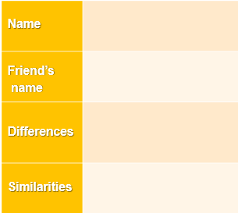  四. Read Paragraph 1 carefully and fill in the blanks.  Jeff Green  五. Read Huang Lei’s part and finish the task.  - ( ) Should friends be the same or different in Huang Lei's eyes?  A. be the same B. be different C. don't care  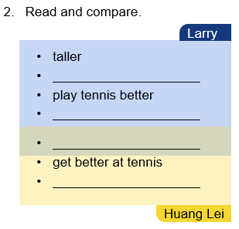  六. Read Mary Smith’s part and answer the questions.  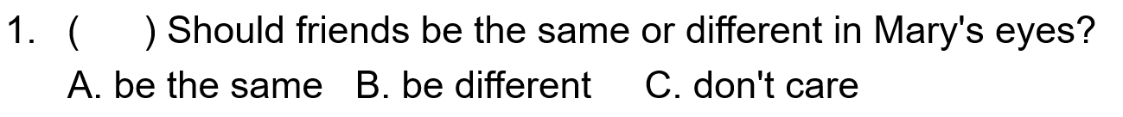  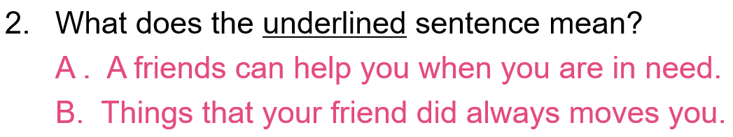  - 完成课本上 P22页 2c，判断正误，并改错。
反馈固学 | 一、单项选择  1.It's not ________ to buy any meat , because we still have some.  A. terrible B. serious C. dangerous D. necessary  2.---Would you please help me get the kite back from the tree ? --- I can't __________ it.  A . see B. arrive C. bring D. reach  3．—How difficult physics it is! I really want to drop it!  —_______ you work hard，you will do it better.  A. As long as B .As soon as C .Though D．While  二、 根据汉语意思及括号内所给英文提示语，将下列句子翻译成英语。  1. 我的朋友们随时都能帮我。(be always there to ...)  2. 她不在乎他们的房子大还是小。 ( not care if ...)  3. 他们没有必要来这儿。 (it's not necessary ...)  4. 那就是我爸爸为什么经常熬夜的原因。(that’s why ...)  5.她是一个外向的女孩，常常逗我笑。(make ... laugh)

